**Exercise 2: Implementing the Factory Method Pattern**

**1.Document.java**

**package** com.factory;

**public** **interface** Document {

**void** StartOpen();

}

2. **DocumentFactory.java-Abstract class:**

**package** com.factory;

**public** **abstract** **class** DocumentFactory {

**public** **abstract** Document createDocument();

}

3. **ExcelDocument.java**

**package** com.factory;

**public** **class** ExcelDocument **implements** Document {

@Override

**public** **void** StartOpen() {

System.***out***.println("Opening an Excel document.");

}

}

**4.ExcelDocumentFactory.java**

**package** com.factory;

**public** **class** ExcelDocumentFactory **extends** DocumentFactory {

@Override

**public** Document createDocument() {

**return** **new** ExcelDocument();

}

}

**5. PdfDocument.java**

**package** com.factory;

**public** **class** PdfDocument **implements** Document {

@Override

**public** **void** StartOpen() {

System.***out***.println("Opening a PDF document.");

}

}

**6. PdfDocumentFactory.java**

**package** com.factory;

**public** **class** PdfDocumentFactory **extends** DocumentFactory {

@Override

**public** Document createDocument() {

**return** **new** PdfDocument();

}

}

**7. TestFactoryMethod.java**

**package** com.factory;

**public** **class** TestFactoryMethod {

**public** **static** **void** main(String[] args) {

// Creating the Word document using factory

DocumentFactory wordFactory = **new** WordDocumentFactory();

Document wordDocument1 = wordFactory.createDocument();

wordDocument1.StartOpen();

// Creating the PDF document using factory

DocumentFactory pdfFactory = **new** PdfDocumentFactory();

Document pdfDocument1 = pdfFactory.createDocument();

pdfDocument1.StartOpen();

// Creating the Excel document using factory

DocumentFactory excelFactory = **new** ExcelDocumentFactory();

Document excelDocument1 = excelFactory.createDocument();

excelDocument1.StartOpen();

}

}

**8. WordDocument.java**

**package** com.factory;

**public** **class** WordDocument **implements** Document {

@Override

**public** **void** StartOpen() {

System.***out***.println("Opening a Word document.");

}

}

**9. WordDocumentFactory.java**

**package** com.factory;

**public** **class** WordDocumentFactory **extends** DocumentFactory {

@Override

**public** Document createDocument() {

**return** **new** WordDocument();

}

}

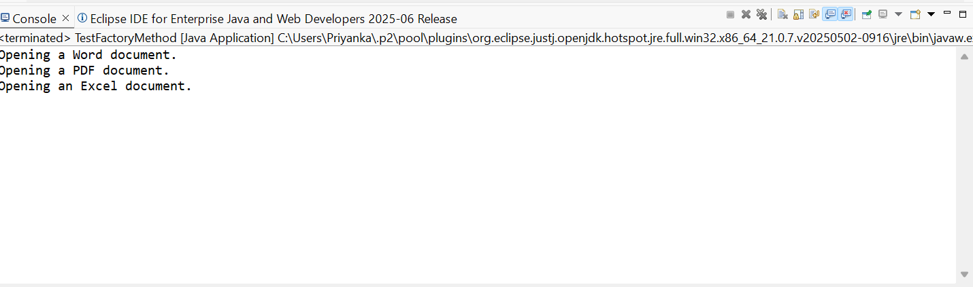**OUTPUT:**